root@cyberster:~$
DAY 2 — VIRTUALBOX LAB SETUP
Network Architecture for a Simplified SOC Lab
// 01 OBJECTIVE

Today's task was to build the virtualized environment that carries the SOC lab through Phase One: a network of isolated virtual machines that can talk to each other and reach the internet, without interfering with each other or the host. This is the foundation everything else — Wazuh, log monitoring, agent enrollment — is built on top of.
The original task scope called for three VMs (Kali Linux, Ubuntu Server, and a Windows 10 monitored endpoint). The lab design was adapted to use the host machine (Windows 11) itself as the monitored endpoint instead of a third VM — this is a valid and resource-efficient SOC lab pattern, and it is reflected throughout this report.
// 02 ENVIRONMENT OVERVIEW

MACHINE | ROLE | TYPE | OS
Windows 11 Host | Monitored endpoint (Wazuh agent) | Physical host | Windows 11
Kali Linux | Attacker machine | VirtualBox VM | Kali Linux (rolling)
Ubuntu Server | Wazuh manager install target | VirtualBox VM | Ubuntu Server

// 03 VIRTUAL MACHINE SPECIFICATIONS

VM | vCPU | RAM | Storage | Status
Kali Linux | 2 cores | 4 GB | 50 GB | DONE
Ubuntu Server | 2 cores | 8 GB | 50 GB | DONE

VirtualBox and the Extension Pack were installed on the Windows 11 host prior to VM creation, matching the Extension Pack version to the base VirtualBox install.

// 04 NETWORK ADAPTER CONFIGURATION

Each VM requires two network adapters: one Host-Only adapter for stable internal lab communication, and one NAT adapter for internet access. Getting this split right is the single most common failure point in this stage of the lab.
$ 4.1 Adapter 1 — Host-Only
Attached to: Host-only Adapter → Name: VirtualBox Host-Only Ethernet Adapter. This virtual adapter (not the host's physical Wi-Fi/Ethernet card) is what gives every machine on the lab — VMs and host alike — a stable address on the 192.168.56.0/24 internal subnet.
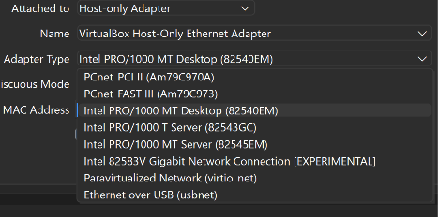
Figure 4.1 — Host-Only adapter configuration (Kali / Ubuntu Server)
$ 4.2 Adapter 2 — NAT
Attached to: NAT. No specific “Name” binding is needed — NAT virtualizes its own connection through whatever physical adapter on the host currently has internet access. “Virtual Cable Connected” confirmed enabled.
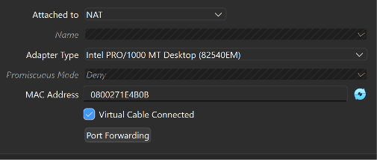
Figure 4.2 — NAT adapter configuration

// 05 IP ADDRESS VERIFICATION

Once both adapters were attached, each machine was checked for two IP addresses — one on the 192.168.56.x Host-Only subnet, and one on a 10.x.x.x / NAT subnet.
$ 5.1 Windows 11 Host
The host itself also receives an address on the Host-Only subnet, since VirtualBox creates a matching virtual adapter on the host side of the network.
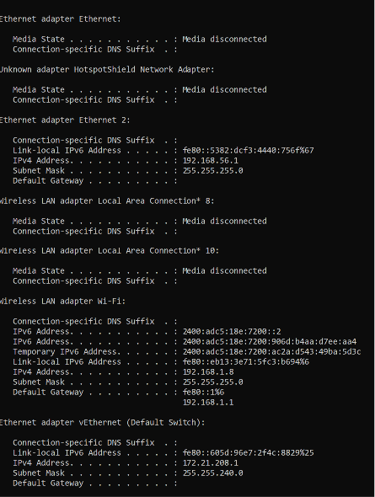
Figure 5.1 — ipconfig output confirming Host-Only IP 192.168.56.1 on the Windows 11 host
$ 5.2 Kali Linux
Kali's Host-Only interface (eth0) initially came up with link state UP but no leased IP — see Section 7 (Troubleshooting Log) for the fix. After resolution, both interfaces show valid addresses:
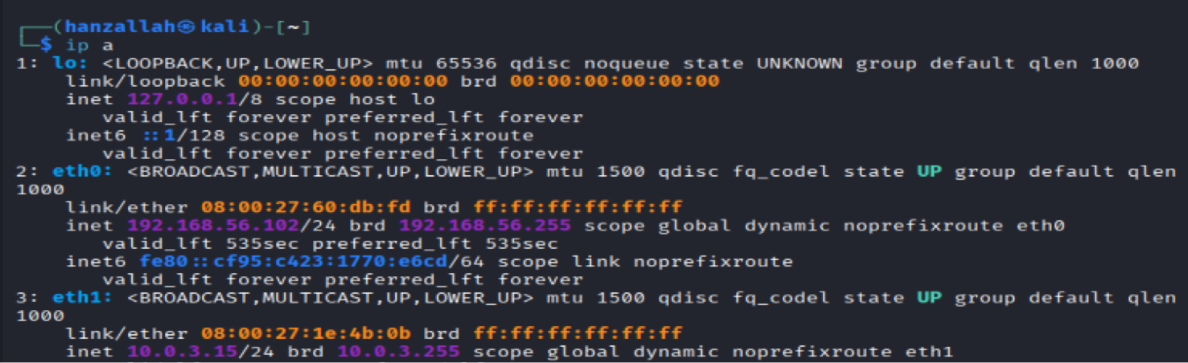
$ 5.3 Ubuntu Server
Ubuntu Server's NAT interface (enp0s8) initially showed state DOWN with no lease — also resolved in Section 7. Confirmed working state:
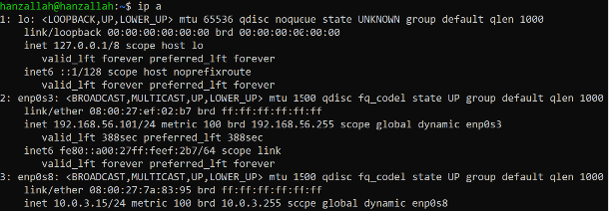
Figure 5.3 — Ubuntu Server `ip a` output, Host-Only address 192.168.56.101 confirmed on enp0s3
// 06 TROUBLESHOOTING LOG

Real environments rarely come up clean on the first try. Documenting issues and resolutions here is itself good SOC practice — this is the same root-cause discipline used when triaging a misbehaving production host.
$ 6.1 Issue — VM Failed to Start (VBOX_E_VM_ERROR / E_FAIL)
Symptom: Ubuntu VM failed to open a session,
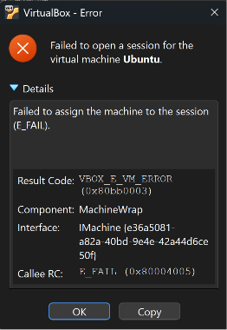
Figure 6.1 — Generic VirtualBox session error on VM start
Root cause: Hyper-V / Core Isolation (Memory Integrity) competing with VirtualBox for control of hardware virtualization on Windows 11 — confirmed by the presence of an active vEthernet (Default Switch) adapter, a Hyper-V artifact.
$ 6.2 Issue — Kali eth0 (Host-Only) Not Acquiring an IP
Symptom: eth0 showed state UP with a carrier signal, but no inet address — while eth1 (NAT) leased normally.
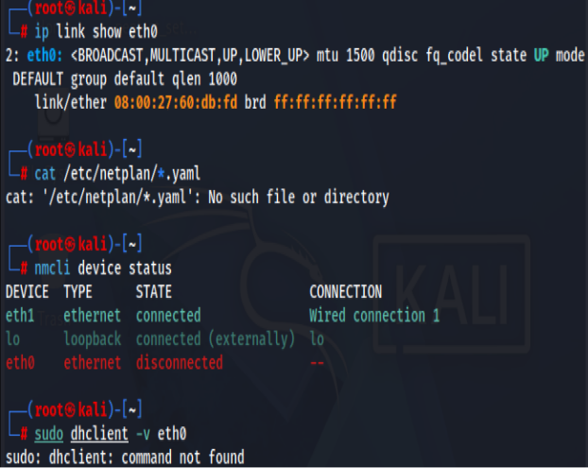
Figure 6.2 — Diagnostic commands on Kali: eth0 up but unleased, eth1 leased, NetworkManager shows eth0 disconnected
Root cause: NetworkManager had no active connection profile bound to eth0.

$ 6.3 Issue — Ubuntu Server enp0s8 (NAT) Missing from Netplan
Symptom: enp0s8 showed state DOWN with no IP. Ubuntu Server uses netplan rather than NetworkManager, and the active config only defined enp0s3.
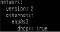
Figure 6.3a — Existing netplan config listing only enp0s3
Resolution: enp0s8 was added to the netplan YAML at the same indentation level as enp0s3:
network:
version: 2
ethernets:
enp0s3:
dhcp4: true
enp0s8:
dhcp4: true
$ 6.4 Issue — Ubuntu Server Could Not Ping Windows 11 Host
Symptom: ping from Ubuntu Server to 192.168.56.1 (host) produced no replies, despite both IPs being correctly configured.
Root cause: Windows Defender Firewall blocks inbound ICMPv4 Echo Requests by default on most network profiles — confirmed via PowerShell, every relevant ICMPv4-In rule was Disabled.
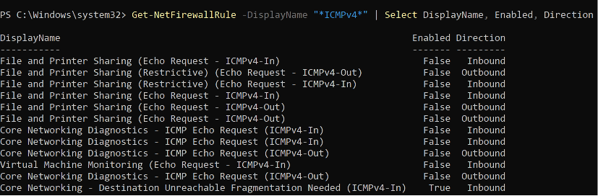
Resolution:
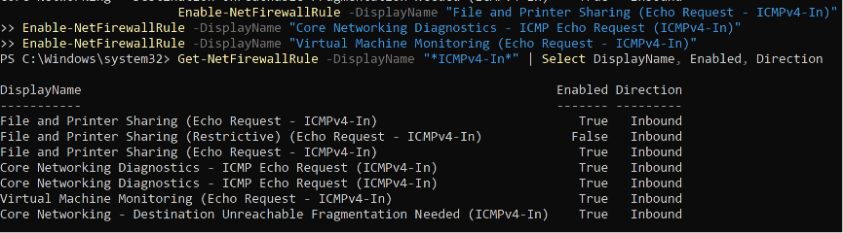
This is a legitimate and reportable finding: inbound ICMP is blocked on Windows hosts by default as a hardening measure, and selectively re-enabling it for the lab subnet is a defensible, documented exception — the kind of firewall rule audit a SOC analyst performs routinely.

// 07 CONNECTIVITY TEST RESULTS

Each machine was tested against the other two over their Host-Only IPs, plus an internet reachability check over the NAT adapter.
FROM | TO | TYPE | RESULT
Kali | Ubuntu Server (Host-Only) | Internal | PENDING
Kali | Windows 11 Host (192.168.56.1) | Internal | PENDING
Kali | 8.8.8.8 (Internet) | External | PENDING
Ubuntu Server | Kali (Host-Only) | Internal | PENDING
Ubuntu Server | Windows 11 Host (192.168.56.1) | Internal | FIXED
Ubuntu Server | 8.8.8.8 (Internet) | External | PENDING
Windows 11 Host | Kali (Host-Only) | Internal | PENDING
Windows 11 Host | Ubuntu Server (Host-Only) | Internal | PENDING

Note: the Ubuntu Server → Windows 11 Host test failed initially due to the ICMP firewall block in Section 6.4. After enabling the relevant inbound rules, this path was confirmed working. Remaining rows above are marked PENDING and should be completed with the final ping screenshots below.
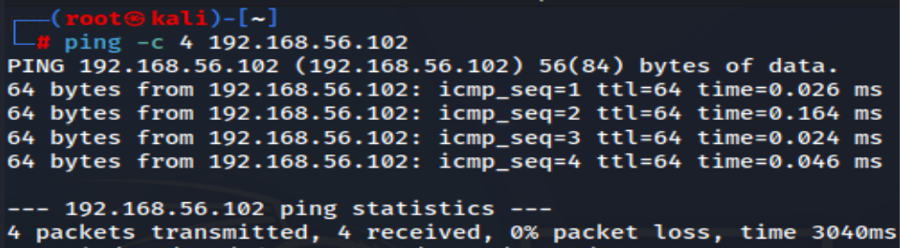
Kali---------Ubuntu Server (Host-Only)
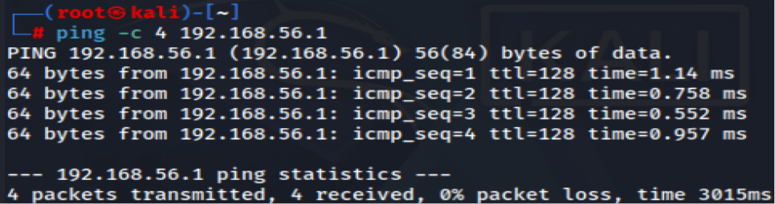
Kali---------Windows 11 Host Machine
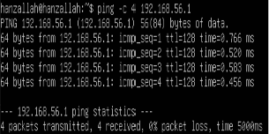
Ubuntu Server-------Windows 11 Host Machine

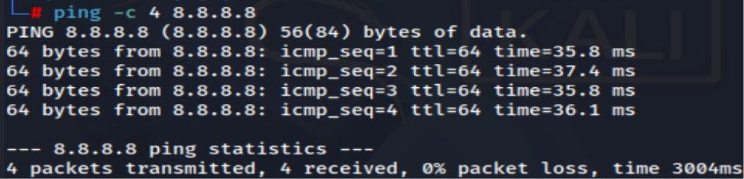
Kali------------------Internet
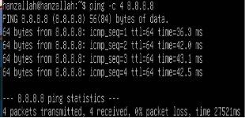
Ubuntu Server------------Internet

// 08 VMS RUNNING SIMULTANEOUSLY
Screenshot of the VirtualBox Manager window showing both Kali Linux and Ubuntu Server in a Running state at the same time, confirming both VMs are stable and operating concurrently on the host.
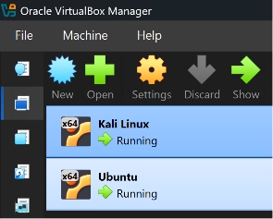
// 09 SNAPSHOTS

A snapshot was taken of each VM once its network configuration was confirmed working, providing a safe rollback point before beginning Wazuh installation.
VM | Snapshot Name
Kali Linux | Kali-Day2-NetworkConfigured
Ubuntu Server | UbuntuServer-Day2-NetworkConfigured

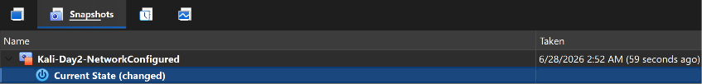
Kali Linux
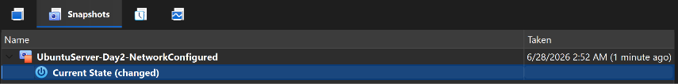
Ubuntu Server
// 10 KEY TAKEAWAYS

- A two-adapter design (Host-Only + NAT) is non-negotiable for a functioning SOC lab — missing either one isolates the machine or cuts off internet access.
- Default Linux network managers (NetworkManager on Kali, netplan on Ubuntu Server) do not always auto-bind every detected interface — always verify with ip a after first boot, not just assume DHCP ran.
- Windows 11's Hyper-V / Core Isolation features can silently block VirtualBox VM startup; the vEthernet (Default Switch) adapter in ipconfig is a reliable tell.
- Windows Defender Firewall blocks inbound ICMP by default — a one-way ping failure between a Linux VM and a Windows host is a firewall question before it's a network question.
- Snapshots taken now (post-network-config) are the rollback point for the Wazuh install ahead — if that breaks something, the network layer itself is preserved.
Environment is now stable and ready for Day 3: Wazuh manager installation on Ubuntu Server.

